CS 255 System Design Document

UML Diagrams

UML Use Case Diagram
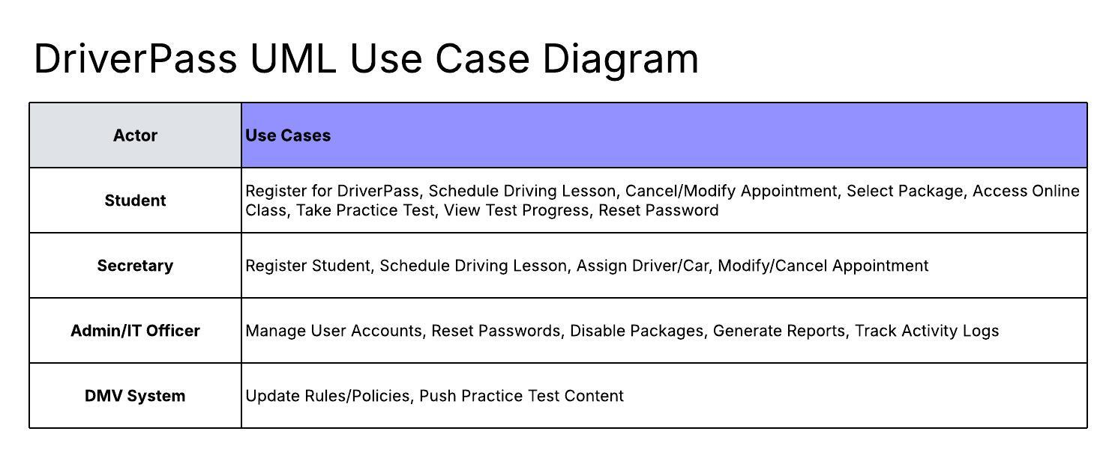

UML Activity Diagrams
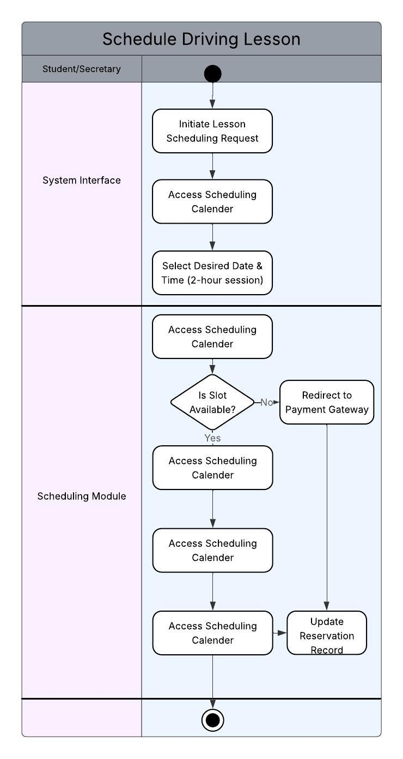

UML Sequence Diagram
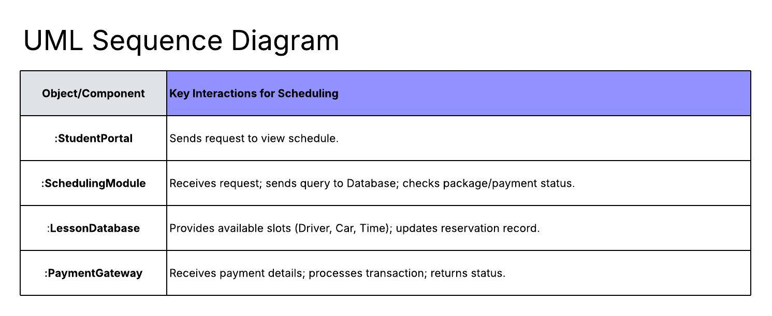

UML Class Diagram
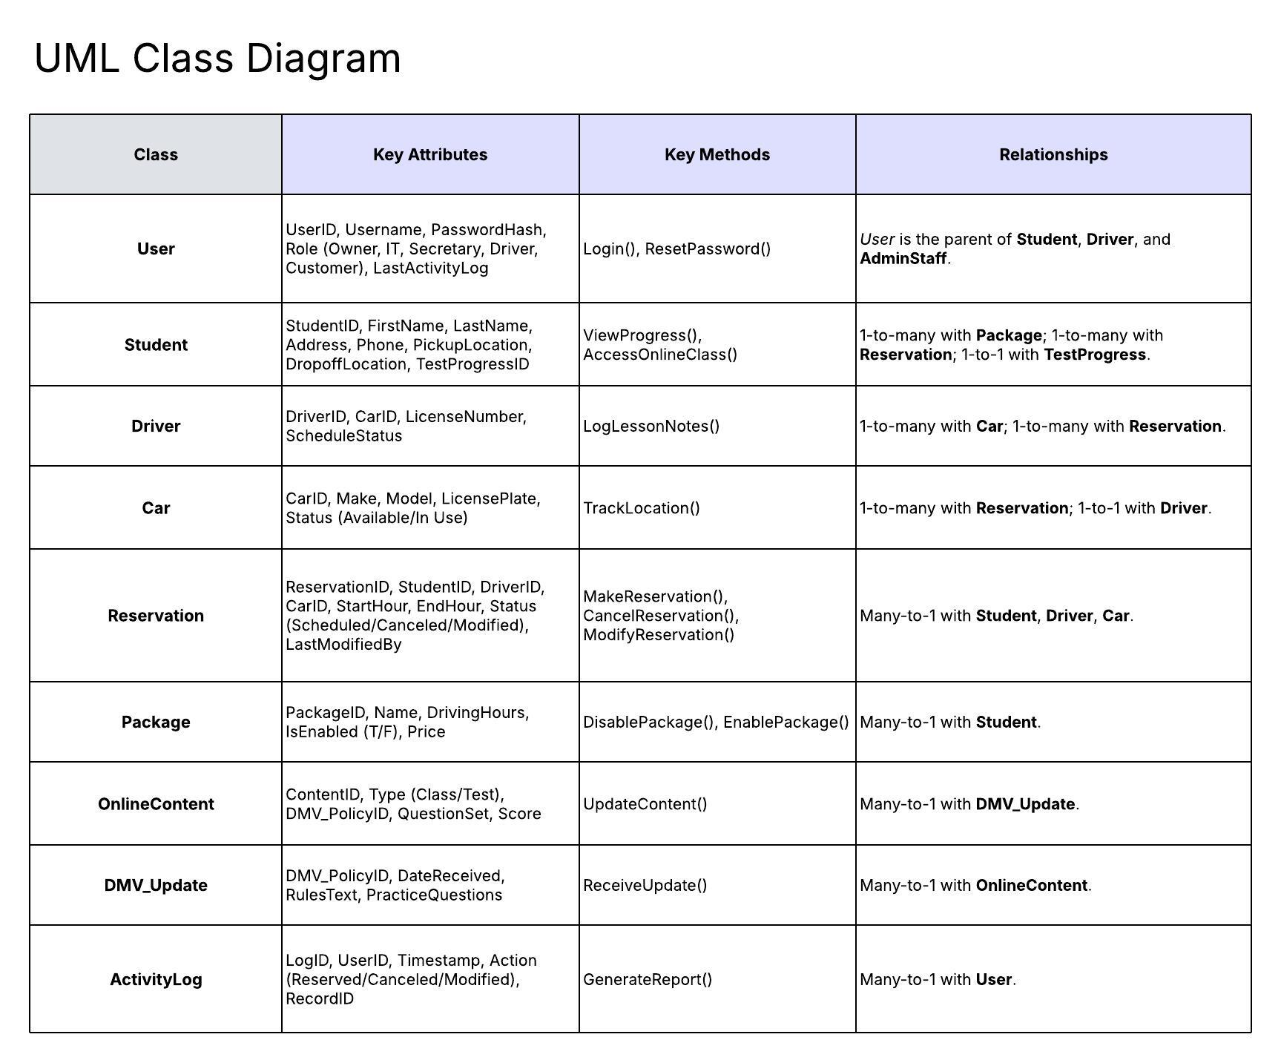

Technical Requirements
The proposed DriverPass system is a cloud-based web application with a relational database. The following technical requirements address the necessary hardware, software, tools, and infrastructure to implement this design.

1. Infrastructure and Hardware Requirements
- Hosting: The application and database must be hosted on a secure, scalable cloud infrastructure (e.g., AWS, Azure, Google Cloud Platform). This offloads backup and security management.
- Database Server: A cloud-hosted robust relational database management system (e.g., PostgreSQL, MySQL, SQL Server) is required to manage the complex many-to-many relationships between users, drivers, cars, lessons, and packages.
- Web Server: A high-availability web server environment to ensure the system is accessible via any computer or mobile device.

2. Software and Tool Requirements
- Front-End Technology: The User Interface must be built using web-based technologies (e.g., HTML5, CSS, JavaScript framework like React or Angular) to ensure accessibility across all standard web browsers on both desktop and mobile platforms. The interface must be responsive.
- Back-End/Programming Language: A secure, scalable server-side programming language (e.g., Python, Java, C#, or Node.js) should be used to build the Business Logic component and manage the database link.
- Database Connectivity Tools: Secure drivers and APIs are necessary to Link DB to Interface and manage the relational data structure.
- Payment Gateway Integration: The system requires an integration with a secure, third-party payment gateway (e.g., Stripe, PayPal Pro) to securely process credit card payments. This integration must handle the secure submission of card number, expiration date, and security code.
- DMV Update Mechanism: Software to consume an external technical mechanism (e.g., an API, regular data feed, or notification service) from the DMV is assumed and required to receive automatic updates on rules and practice questions.

3. Security and Performance Requirements
- Security Protocol: All data exchange between the client and the server, especially credit card information, must be secured using protocols like SSL/TLS encryption.
- Authentication and Authorization: The system requires software to implement role-based security to ensure different users (Owner, IT, Secretary, Driver, Customer) have distinct rights and access levels. This includes full administrative privileges for the IT Officer.
- Activity Logging: A component must be implemented to automatically log and attribute all user actions (reservations, cancellations, modifications) to a specific user for accountability.
- Performance: The system must be designed for responsiveness, ensuring that data access and report generation are fast. The interface must dynamically show updates in test progress and lesson times.

